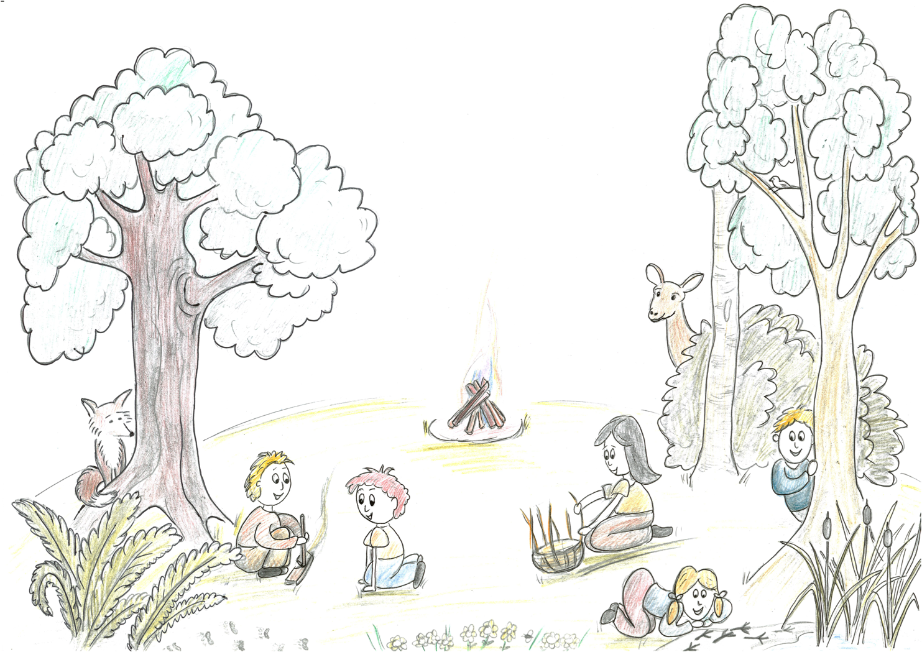
Dear Parents,

I am thrilled with the positive feedback we have had streaming in throughout the past year. My personal motivation for this work is to help develop connections for others to self, each other and nature.

Following last years successful Community Craft Camp we have decided to hold it as an annual event. We’ve listened to your feedback and have done our best to keep all the good things and fine tune the rest. As requested, we’ve made it a little longer, we’re returning to the same beautiful site and all is lined up for Eloise to come back and oversee the delicious family friendly food again.

We’ve done our best to make this community craft camp both financially accessible and to be able to pay the craft specialists and chef an honourable wage. We feel it will be most nourishing for food to be provided by our wonderful chef and we will strive to provide good quality, local organic produce where possible.

I’m looking forward to connecting with you all, to crafting and seeing all your wonderful hands at work, experiencing different textures and materials under tuition of our cherry-picked team. To enable adults to get into the crafts for 2x 2hour sessions each full day the children will be off on adventures including some of their own craft projects in the woods with experienced nature mentors. We look forward to wide games in the afternoon whilst those less energetic may continue their crafts informally during this time. Being out under the stars and looking out for shooting ones, stories and songs around camp fires… So looking forward to it!

It will be a limited group, so please return the following booking form at your earliest convenience to avoid disappointment.

In gratitude for your on-going support,

Warmest wishes,

Vicky Mew

What to expect:

Cultivating Curiosity Community Craft Camp will run from the afternoon of Wednesday 2nd August until the afternoon of Sunday 6th August 2016 at: Colin Godman’s Farm, Furners Green, East Sussex – directions to follow nearer the time.

The adults will have opportunities to participate in facilitated craft sessions with experienced crafts folk as detailed on our website. This will be at minimum 7 x 2 hour sessions throughout the 5 days with the opportunity for more in a less structured way. Children will take part in creative and practical activities within a natural environment with experienced Nature Mentors during these 7 x 2 hour sessions and possibly more. Older, more mature children (10+) who want to embark on a more craft-centred week will have their own group with experienced nature mentor where this will be the focus.
We will be finalising the design of the camp nearer to the time when we have an idea of who is participating and how many of each age group. It will be similar to last year but with an additional group specifically for older children who want to focus on crafts so that adults feel they get the quality time with their craft specialist. We are imagining a community feel with different clans who you’ll get to know in addition to those who’re joining you in your crafting sessions. Clans will provide a basis for a few smaller group check-ins and also for some accessible smaller group games. Each clan will be on a rota, please expect to muck in with the camp maintenance twice a day. These contributions will include: helping our chef in the kitchen with food prep, helping with washing up kitchen dishes, wooding to keep our central fire fed and a toilet check to top up handwash and toilet rolls when needed. We will each wash our own individual dishes.

Kit List:
You will need to bring:
- Camping equipment for your group: tent, insulation mat, sleeping bag, extra blanket, (pillow)
- Labelled eating utensils (mug, bowl, plate, cutlery and water bottle)
- Clothes for all British summer weathers including waterproofs and sunhats – Layers!
- Toiletries – toothbrush, toothpaste, flannel (there will not be a shower at this camp, we can set up a simple bucket and ladle enclosed area if requested)
- Towel and swim suit – there is a lake that we will likely be able to swim in, TBC.

You may want to bring:
- Any existing craft projects that you’d like to work on during the camp
- Torch
- Acoustic musical instruments
- Your own craft knife so long as it is either a fixed blade knife or can lock out when open and blade length of 10cm or less
- Folding chair, seat, cushion or rug
- Snacks

Terms and Conditions:
We reserve the right to cancel a programme if insufficient places have been booked and confirmed in which case you would receive a full refund. We also reserve the right to cancel part or all of the camp in extreme weather conditions in which case an appropriate refund will be made dependant on how much of the camp was cancelled.

Course participants must expect to have the opportunity to be involved in creative, adventurous and sometimes strenuous activities. No previous training or experience is required but you must be of good general health. A medical declaration form must be completed and returned to us on confirmation of your booking. If you are under 16 years of age, your parent/guardian must sign the form. We can take no responsibility in the event of any ailment or aggravation of ailment suffered either during or after the camp that arises from an undeclared injury or illness.

Cultivating Curiosity states that woodlands & other natural habitats are potentially hazardous environments. Whilst we alert participants to these possible dangers it is impossible to cover all such hazards & dangers. The following require the most specific attention: Risk of falling deadwood; trip hazards such as logs, roots, brambles, burrows; poisonous plants; eye level hazards such as twigs, branches, ticks that could be carrying lymes disease etc. Adults making this booking are fully aware that there may be risks involved during a Cultivating Curiosity programme even where best practices for managing risk are followed.

Forest School practitioners and nature mentors teach basic woodland skills, the appropriate use of tools where relevant to an activity and an appreciation of the natural world. They allow for a good amount of child led learning. All lead staff are certified First Aiders with experience in facilitating fun learning outdoors. All lead staff are CRB/DBS checked (any support staff that may not have a current DBS check are not left alone with any children and are always in sight of a lead staff member) All staff have had at least 2 reference checks.

Cancellation Policy:
If you cancel your booking within a week of having booked we are able to refund your payment (including the deposit).

If you cancel your booking after a week of having booked, the deposit (half the full amount of your group’s booking) is non-refundable. Any surplus payment can be refunded up to one month before the event.

Programme dates: Community Craft Camp – 2nd- 6th August 2017
Names and ages of all those in your group……………………………………………………
………………………………………………………………………………………………………

Parent/Guardian/Next of Kin (full name):
………………………………………………………………………………………….
Home address:
………………………………………………………………………………………….
Email address:
………………………………………………………………………………………….
Contact telephone numbers and names in case of emergency:
1.…….………….…………………………..… 2.…..….………….……………………..…….

Does anyone in your group suffer from any medical conditions we should be aware of? For example, asthma, hayfever, allergies to stings, bites or foods. Please give details:
…………………………………………………………………………………………..
…………………………………………………………………………………………

Does anyone in your group have any behaviours we should be aware of? Please provide details:
…………………………………………………………………………………………..
…………………………………………………………………………………………

Do you agree to all those in your group receiving First Aid treatment if needed? YES / NO
I give permission for photos of my child to be used in promotional material or for funding opportunities and other projects by Cultivating Curiosity YES / NO

As parent/guardian of the child named above, I have read the terms and conditions of this programme and the cancellation policy and agree to participation for all those in my family named above.

Signed……………………………………………….Date……………………………
Name (in print) ……………………………………..
I enclose payment as detailed on the next page. Return to: info@cultivating-curiosity.co.uk
Adult Crafter’s interests:
Please let us know the adults’ craft preferences. This year we will have a primary craft activity that you book onto. This will enable a core group of approximately 8-10 adults to immerse in one material with one craft specialist for the first 3 craft sessions. The remaining craft sessions will be more open and there will be some shorter projects on offer with the opportunity to try other crafts or continue with your primary one.

Please number your priority (1 being your first choice 4 being your least preferred). We will do our best to update the website when a group has reached its maximum capacity – you can still indicate your preference in case of a cancellation though even when a group is full.
Primary adult craft projects | Name of Adult 1 | Name of Adult 2 | Name of Adult 3
Leatherwork
Weaving willow or rush
Metal Casting
Wood craft

Additional craft activities available in at least one of the open craft sessions to include:
Wool Dyeing, Wild Fire, Foraging, Plant fibre cordage, Wild Pottery

Payment Details:

Please fill in the left column of the table below to indicate how many places of each category you are booking.

Quantity in group | Cost | Who
 | £240  EB £220 | Adult who is able to join craft sessions (not accompanying an under 3)
 | £180 | Craft group for older children and teens 10+
 | £180 | Children 7-12
 | £180 | Children 3-6
 | £120 | Adult accompanying an under 3 and therefore unable to join main craft sessions
 | Free | Under 3s

(Early bird offer - £20 off each adult booking when booked before April 15th)
Our total cost is= £……….

Please send either full payment or a non-refundable deposit for half payment with the booking form as places can only be reserved when payment is received. Full payment must be completed by Wednesday 19th July at the latest (a fortnight before the camp).

Cheques payable to: Cultivating Curiosity, 21 Verbania Way, East Grinstead RH19 3UP
For BACS transfers, bank details are:
Cultivating Curiosity sort code: 08-92-99 account number: 69680403

Any questions, please contact Victoria Mew: 07540617851 info@cultivating-curiosity.co.uk

Optional Further information:
Please let us know if you or any of your family have any experience or particular interests you’d like us to know about:

Do you have any concerns regarding camping arrangements or any requests to meet your families needs that would be helpful for us to know about in advance?

Looking forward to a rich time in the woods with you and enjoying spacious time to get creative!

